**MENU**

* [Home](https://www.cussons.co.uk/homepage.php)
* [Educational Products](https://www.cussons.co.uk/engineering-educational-division.php)

**EDUCATIONAL PRODUCTS**

[**BACK**](https://www.cussons.co.uk/products/automotive/engine-test-beds.php)

* + [Mechanics of Fluids](https://www.cussons.co.uk/products/mechanics-of-fluids/)
  + [Thermodynamics](https://www.cussons.co.uk/products/thermodynamics/)
  + [Automotive](https://www.cussons.co.uk/products/automotive/)
  + [Environmental & Clean Energies](https://www.cussons.co.uk/products/environmental-and-clean-energies/)
  + [Applied Mechanics](https://www.cussons.co.uk/products/applied-mechanics/)
  + [Process Control Engineering](https://www.cussons.co.uk/products/process-control-engineering/)
  + [Marine Hydrodynamics](https://www.cussons.co.uk/products/marine-hydrodynamics/)
* [Marine Research Products](https://www.cussons.co.uk/products/marine-and-industrial/)
* [About](https://www.cussons.co.uk/about.php)
* [News & Events](https://www.cussons.co.uk/news/index.php)
* [Contact](https://www.cussons.co.uk/contact.php)
* [Privacy Notice](https://www.cussons.co.uk/privacy-notice.php)
* [Privacy Notice](https://www.cussons.co.uk/unsubscribe.php)

[](https://www.cussons.co.uk/)

Top of Form



Bottom of Form

**QUOTE BUILDER** (**0**) ITEMS

VIEW



Powered by [**[Google Translate](https://translate.google.com/)Translate**](https://translate.google.com/)

VIEW MENU

* Educational  
  Product Categories
* **Materials Properties**
* **Structures**
* **Mechanics of Fluids**
* **Aerodynamics & Air Flow**
* **Thermodynamics**
* **Steam**
* **Automotive**
  + [Category Overview](https://www.cussons.co.uk/products/automotive/)
  + [**Engine Test Beds**](https://www.cussons.co.uk/products/automotive/engine-test-beds.php)
  + [Autotrainers](https://www.cussons.co.uk/products/automotive/autotrainers.php)
  + [Instrumentation & Accessories](https://www.cussons.co.uk/products/automotive/instrumentation-accessories.php)
  + [Automotive Fuel & Gas Analysers](https://www.cussons.co.uk/products/automotive/automotive-fuel-gas-analysers.php)
* **Environmental & Clean Energies**
* **Applied Mechanics**
* **Process Control Engineering**
* **Marine Hydrodynamics**

**Engine Test Beds**

Laboratory testing of internal combustion engines is an important topic on many mechanical, automotive and energy engineering courses and it is a vital part of the product development and quality control processes within the automotive manufacturing industry. Cussons has designed and manufactured engine dynamometer test beds since the 1930s and the current range includes bench-top entry level single cylinder models, larger floor standing models with additional features and large multi-cylinder units optimised in different ways. The larger units may be customised with dynamometers for higher speeds and/or power outputs, modified for more exotic fuel mixtures or designed specifically to meet Formula Student requirements for instance. Large multi-cylinder units are offered which allow petrol and diesel engines to be exchanged easily by the end user and others have permanently fixed engines optimised for lowest cost.

* [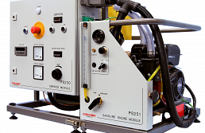](https://www.cussons.co.uk/products/automotive/engine-test-beds.php?s=p8250-automotive-1-engine-test-bed-petrol-diesel-engine-options) P8250 - Automotive 1 Engine Test Bed – Petrol & Diesel Engine Options

[View Product](https://www.cussons.co.uk/products/automotive/engine-test-beds.php?s=p8250-automotive-1-engine-test-bed-petrol-diesel-engine-options)

* [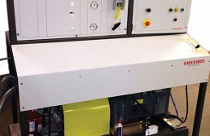](https://www.cussons.co.uk/products/automotive/engine-test-beds.php?s=p8160-single-cylinder-engine-test-bed-engine-options-up-to-7kw)

P8160 - Single Cylinder Engine Test Bed - Engine Options Up To 7kw

[View Product](https://www.cussons.co.uk/products/automotive/engine-test-beds.php?s=p8160-single-cylinder-engine-test-bed-engine-options-up-to-7kw)

* [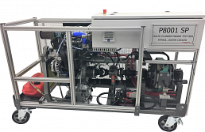](https://www.cussons.co.uk/products/automotive/engine-test-beds.php?s=p8001p8002-multi-cylinder-engine-test-beds)

P8001 - Multi-cylinder Engine Test Beds

[View Product](https://www.cussons.co.uk/products/automotive/engine-test-beds.php?s=p8001p8002-multi-cylinder-engine-test-beds)

* [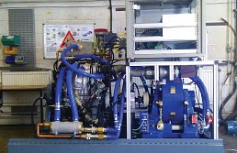](https://www.cussons.co.uk/products/automotive/engine-test-beds.php?s=p8750-multicylinder-engine-test-bed-multiple-engine-options)

P8750 - Multicylinder engine test bed - multiple engine options

[View Product](https://www.cussons.co.uk/products/automotive/engine-test-beds.php?s=p8750-multicylinder-engine-test-bed-multiple-engine-options)

* [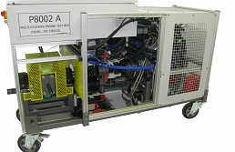](https://www.cussons.co.uk/products/automotive/engine-test-beds.php?s=p8002-multicylinder-engine-test-bed-diesel)

P8002 MULTICYLINDER ENGINE TEST BED, DIESEL